TUSEF e-Donation Policy

Background | The Thailand–United States Educational Foundation (TUSEF), also known as Fulbright Thailand, has been a cornerstone of educational exchange for over 75 years. Historically, TUSEF has not solicited donations; however, a few individuals have contributed voluntarily.  As a registered Thai foundation, TUSEF operates as a non-profit organization and is tax-exempt under Thai law. Donors who pay taxes in Thailand are eligible for a 100% tax deduction on their donations, as recognized by the Thai Revenue Department.  This policy outlines the framework for accepting and managing donations to Fulbright Thailand. It ensures transparency, accountability, and alignment with the Foundation’s mission to foster educational exchange and make meaningful contributions to society.
Donation  QR Code | TUSEF has received an official QR code for e-donations. This QR code facilitates easy contributions and ensures automatic recognition by the Thai Revenue Department for tax deduction purposes. While TUSEF will NOT publicly solicit donations, discrete fundraising efforts will be conducted during alumni gatherings and special events.
Voluntary Donations and Recognition | During alumni events, attendees may be encouraged to donate. Donors contributing at specific levels may receive modest tokens of appreciation, such as Fulbright-branded items (e.g., pins, polo shirts, tote bags). In addition, fundraising events may be organized to attract contributions from companies and generous individuals in support of meaningful causes aligned with Fulbright Thailand’s mission.
Governance and Oversight | To ensure responsible use of donated funds, a Donation Oversight Subcommittee will be established. The subcommittee will comprise four members:  - Two representatives from the American Board members.  - TFA President or their representative to represent Fulbrighter interests.  - One Thai Board member or their representative.  The subcommittee will review the donation account and recommend fund utilization plans by the end of September each year. These plans will be presented to the full board for approval.
Fund Categories | Donations will be allocated to the following fund categories:  - General Fund: Supports Fulbright Thailand’s regular programs. Voluntary donations without specific terms of use will be added to the General Fund, supplementing annual contributions from the U.S. and Thai governments.  - Fulbright Alumni Impact Fund: Supports Fulbright alumni-led projects that benefit communities or educational institutions.  Donations collected during alumni events will be automatically allocated to this fund. TUSEF will work with the subcommittee to issue calls for proposals for Fulbright alumni to apply for grants under this fund.  - Other Funds: Additional fund categories may be created based on emerging needs, donor interests, or specific fundraising initiatives. These may include special events organized for fundraising purposes, targeted campaigns supporting specific programs or communities, and named funds established in honor of individuals or companies.
Transparency and Reporting | TUSEF will maintain clear records of all donations and fund usage. Annual reports, including summaries of grant activities, will be shared with the Board and may be made available to donors upon request.
Contact Information | For any inquiries regarding this policy or donation procedures, please contact finance@fulbrightthai.org
Last updated | September 26, 2025

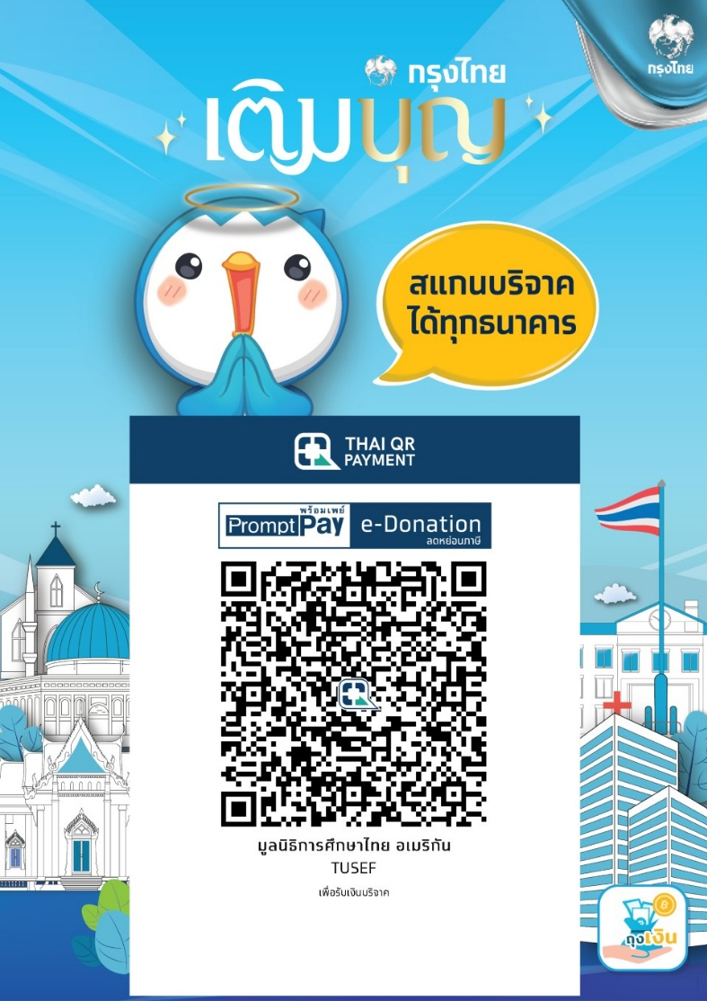

Fulbright Thailand @ 75: Celebrate and Elevate
Join us in celebrating our Fulbright alumni community and supporting initiatives that strengthen connections and impact. Your contribution helps make this event memorable and meaningful for everyone.

Why Support Us?
Your contribution helps Fulbright alumni turn ideas into action and benefits communities across Thailand. By supporting the Fulbright Alumni Impact Fund, you will:
- Empower alumni-led projects
that improve education, community development, and social impact.
- Multiply the Fulbright impact,
extending the program’s benefits to a wider audience.
- Ensure accountability and transparency,
with projects selected by the Donation Oversight Subcommittee and progress shared via TUSEF social media.
- Strengthen the Fulbright Thailand family,
fostering connections among alumni, grantees, and supporters.
- Inspire future generations,
showing how alumni contributions create lasting change.

Donation Tiers
 |  | Fulbright Thailand branded items
Level | Amount | Mascot  (pre-order) | Polo shirt | Tote bag | Pin
Diamond | 5,000+ THB
Platinum | 3,000 THB
Gold | 1,500 THB
Silver | 1,000 THB
Bronze | 5,00 THB

In-Kind Contributions
We also welcome in-kind support, such as
- Venue sponsorship
- Your expertise as speakers, workshop facilitators, interviewers, consultants, etc.

How to Contribute
- Donations can be made via QR code (automatic recognition by the Thai Revenue Department for tax deduction purposes)
- In-kind contribution could be discussed via info@fulbrightthai.org

Contact
For more information or to discuss tailored sponsorship opportunities, please contact info@fulbrightthai.org

